**INNOVATORS**

**PROJECT PHASE 2**

**TITLE: LPG GAS LEVEL MONITORING AND LEAKAGE DETECTION**

**PROBLEM STATEMENT:**

Many times LPG gas cylinder in our home goes empty. And if the LPG gas provider agency does not deliver gas on time then we face many problems due to unavailability of LPG gas. Another major problem is that many times accidentally there is LPG gas leakage. Which can cause fire in house. To avoid above two problems, suggest a solution to slove these problem.

**OBJECTIVE:**

1. To design and develop a LPG Gas leakage monitoring & alert system using Arduino.
2. To display the leakage alarm on a display board and send an alarm notification on SMS to any predefine mobile number.

**SOLUTION:**

Weight sensor(Load cell) is used to detect if the cylinder is empty of not. If the cylinder is empty then an alert is given with the help of buzzer. Also a sms is sent to the owner. This project measures and displays the value of LPG gas leakage. LCD display connected to this project displays this value of LPG gas. LPG gas sensor is used to detect the gas leakage. If there is leakage then buzzer is turned on. GSM modem is used to send the SMS whenever there is gas leakage.

**BLOCK DIAGRAM AND ITS WORKING:**

GSM MODULE

ARDUINO UNO

REGULATOR

LOAD CELL

HX711

AMPLIFIERR

LPG GAS SENSOR

LCD DISPLAY

BO METER

**1) Weight sensor:**

We have used load cell as a weight sensor. The function of load cell is to give output voltage as per the force/weight applied to it. Sensor converts the applied force into corresponding electrical signal. The output of weight sensor is in analog form. It is given to a HX711 amplifier which comes with this weight sensor. Function of HX711 amplifier is to give digital output which is proportional to analog input received from weight sensor. This digital output is given to microcontroller for further processing. We have used a weight sensor of 40 kg capacity. So 40 kg is the maximum weight that can be applied to this weight sensor.

**2) ARDUINO UNO Microcontroller:**

Various functions of Arduino Uno micro controller are:  
i) Read the input from weight sensor HX711 amplifier which is in digital format.  
ii) Calculate the weight which is corresponding to this digital input.  
ii) Read input from LPG gas sensor  
iii) Display these data on LCD display.  
iv) Find out whether the weight is above the threshold weight level or below the threshold weight level.  
v) To turn on the buzzer when threshold level crossed or LPG gas leakage is detected  
vi) To communicate with GSM modem to send the SMS to the owner of gas cylinder.

**3) LPG gas sensor:**

It is used to detect LPG gas leakage. It gives analog output voltage which is proportional to the LPG gas sensed.

**4) GSM Modem:**

GSM modem is used for sending SMS so that user can get remote indication. GSM modem is used to send SMS to user about the situation of gas cylinder like threshold is cross or gas level is 20%, gas level is below 5%. Arduino Uno Microcontroller communicates with GSM modem and sends commands to GSM modem. Thus a text SMS is sent to the owner of the gas cylinder.

**5) LCD Display:**

We have also provided Liquid Crystal Display (LCD display) to this system. We have used 16by2 alphanumeric display. LCD display shows actual weight of the gas and at the same time it shows various status messages like “Sending SMS”, “SMS sent” and “Gas has reached to 20% value” or “Gas has reached to 5% value”. All these kind of messages are shown on the LCD so that person operating this project can read these message. LCD display is useful in testing purposes as well.

**6) Buzzer:**

Buzzer is used to indicate the user about the threshold level. Buzzer is provided with this system which is turned on after LPG gas leakage. Then the people near gas cylinder come to know about the status of the gas.

**CIRCUIT DIAGRAM:**

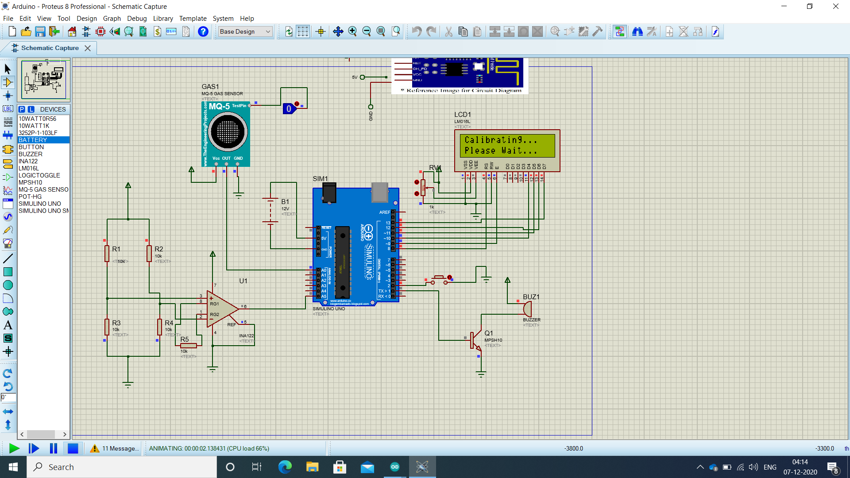

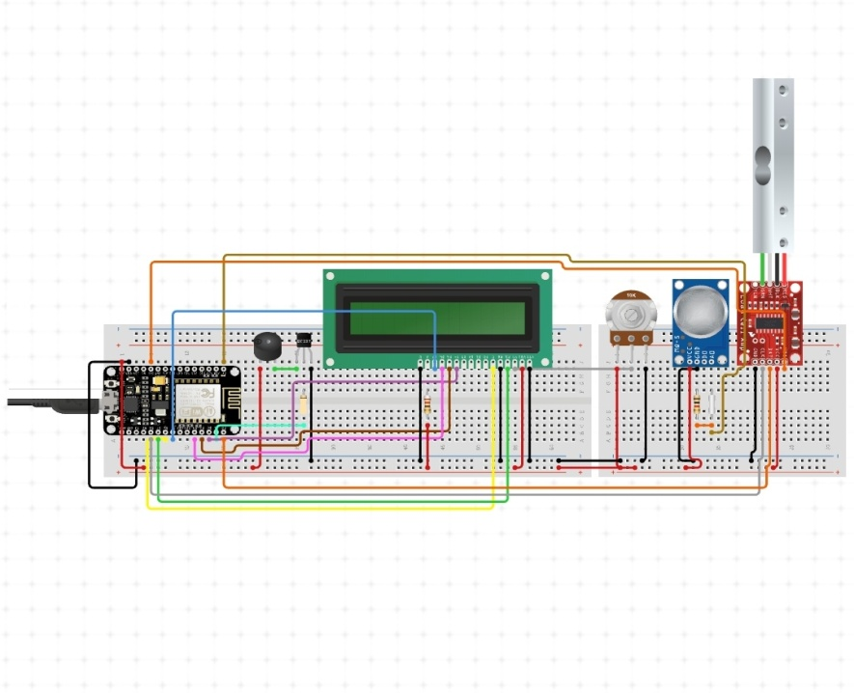

**CODING:**

#include <LiquidCrystal.h>  
LiquidCrystal lcd(8, 9, 10, 11, 12, 13);  
  
#define loadcell A5  
#define sensorvalue A5  
#define sw 1  
#define MQPin A0  
#define buzzer 2  
  
  
  
  
long sample=0;  
float val=0;  
long count=0;  
  
  
void setup()  
{  
    
  lcd.begin(16, 2);  
   pinMode(MQPin, INPUT_PULLUP);  
   pinMode(buzzer, OUTPUT);  
    lcd.setCursor(5, 0);  
    lcd.print("GAS");  
    lcd.setCursor(3, 1);  
    lcd.print("DETECTOR");  
    delay(1000);  
    lcd.clear();  
  Serial.begin(9600);  
  pinMode(loadcell, OUTPUT);  
  pinMode(sw, INPUT_PULLUP);  
  lcd.begin(16, 2);  
  lcd.print("    Weight ");  
  lcd.setCursor(0,1);  
  lcd.print(" Measurement ");  
  delay(1000);  
  lcd.clear();  
   
}  
  
void loop()  
{  
  int gas_value = digitalRead(MQPin);  
  
if(gas_value==HIGH)  
{  
  digitalWrite(buzzer, HIGH);  
  lcd.setCursor(6, 0);  
  lcd.print("GAS");  
   lcd.setCursor(3, 1);  
  lcd.print("DETECTED");  
  delay(200);  
  lcd.clear();  
  delay(200);  
    
}  
else  
{  
 lcd.clear();  
 digitalWrite(buzzer, LOW);   
}  
    
  int sensorvalue=analogRead(loadcell);  
  Serial.println(sensorvalue);  
  delay(500);  
    
  Serial.print("weight:");  
  Serial.println("g");  
  lcd.setCursor(0,0);  
  lcd.print("Weight in Kg  ");  
  lcd.setCursor(0,1);  
    
  lcd.print("g             ");  
  
  if(digitalRead(sw)==0)  
  {  
    val=0;  
    sample=0;  
     
    count=0;  
    calibrate();  
  }  
}  
  
void calibrate()  
{  
    lcd.clear();  
  lcd.print("Calibrating...");  
  lcd.setCursor(0,1);  
  lcd.print("Please Wait...");  
  lcd.clear();  
}

**WORKING:**

In this project, we have used a loadcell as a weight sensor. This sensor will be placed below the LPG gas cylinder. The output of the weight sensor is given to the Arduino Uno microcontroller. That microcontroller will continuously monitor the weight of LPG gas. This is calculated by the total weight received by the weight sensor minus the weight of the empty gas cylinder. Because the gas cylinder is made up of metal and it has some weight.

So the actual weight of LPG gas is calculated by the formula below.

**LPG weight = Actual weight received by weight sensor – actual weight of the empty gas cylinder**

Whenever LPG gas weight is 20% remaining, the system sends a low priority or low warning message to the owner of the house or owner of the hotel or industry. So the owner will get SMS. The contents of SMS will be “Weight of LPG gas is below 20% threshold value. The actual weight is XYZ kilogram.” The value of XYZ will be replaced by the value received by the formula given above.

So first a low warning message is sent when there is 20% gas remaining in the cylinder. The second message is sent which has high priority or we can say that it is a critical message when the gas cylinder is just 5% remaining.

So the use of first low priority SMS is that the user gets intimation about the weight of the gas. So he/she can immediately place the order/book a new LPG gas cylinder or gas refilling. In some cases, users can ignore the first SMS because it has low priority but still there is a 20% gas remaining inside the cylinder. 20% means still there are some days for which the user can use the gas and whenever the user receives the second SMS then he/she can immediately give the order for the gas.

**COMPONENTS USED:**

1. Arduino Uno Microcontroller

2. LCD display

3. GSM module

4. Weight sensor (load cell)

5. LPG gas sensor

**CALCULATION:**

**LPG weight = Actual weight received by weight sensor – actual weight of the empty gas cylinder**

**LinkedIn post:**

I'm glad to share my experience on project phase 2.  
Title of our Project:LPG gas level Monitoring and leakage detection  
  
Here, I have learnt on this project which includes a various number of elements such as analysing articles,research papers and writing codes .I have done this project successfully with help of our core mentor [**SREE PAVITHRA**](https://www.linkedin.com/in/ACoAADJ31PUBVFMf9o1xFl6zq6dK63Udn-gFWzU) and tech mentor [**Harshapradha M**](https://www.linkedin.com/in/ACoAAC0o41cBSloVWBmucd4lDq0EUdfATVS9g08)  
  
"Team work divides the task and multiples the success!"  
So I could not have done this alone without my team [**Archana A**](https://www.linkedin.com/in/ACoAADJcWz8BU78aiHutPFYj4z26SoEwfDd3QU0) [**Sahaya Reshma J**](https://www.linkedin.com/in/ACoAAC4lbTsBXMfhZVjUynm5zdRk2nqBnMbeaUU) [**Abinaya S**](https://www.linkedin.com/in/ACoAAC2FrRMB7IGzeYmUBlAMZLuRVa6bW3A-j80)  
Sharing and discussing different ideas and amount of knowledge amongst the group also gave me a brief insight on how to deal with problems and come up with an applicable solution.  
Thanks to [**INNOVATORS**](https://www.linkedin.com/company/innovators-rsmnr/) and [**NIKHIL SHRIRAM RAVICHANDREN**](https://www.linkedin.com/in/ACoAACfiUYsBlwk7fTkgSabDScd_3WHdFTUcMqE).  
for supporting us throughout this journey !  
  
Click on the link below to view our simulation video!  
[**https://lnkd.in/gRTVf44**](https://lnkd.in/gRTVf44)  
[**#innovators**](https://www.linkedin.com/feed/hashtag/?keywords=innovators&highlightedUpdateUrns=urn%3Ali%3Aactivity%3A6746641575327232000) [**#projectmanagment**](https://www.linkedin.com/feed/hashtag/?keywords=projectmanagment&highlightedUpdateUrns=urn%3Ali%3Aactivity%3A6746641575327232000) [**#team4**](https://www.linkedin.com/feed/hashtag/?keywords=team4&highlightedUpdateUrns=urn%3Ali%3Aactivity%3A6746641575327232000)